LABORATORY OBSERVATION/RECORD
Course: Full Stack Web Development
Course Code: 23CM4121
Task No.: 6
Student Name: EMANDI HARI CHARAN
Roll No.: A24126552080
Date:

1. TITLE
Advanced JavaScript OOP, Node.js Modular Architecture, Package Management, and Express Middleware
2. AIM
To implement four advanced full-stack technical solutions: (1) differentiating JavaScript constructor functions and ES6 classes for object-oriented instantiation, (2) examining Node.js modular architecture using built-in system modules (os, path, fs), (3) managing external package dependencies via NPM and package.json with the uuid library, and (4) developing custom logging middleware within the Express.js request-response cycle.
3. OBJECTIVE
The objectives of this experiment are:
- To contrast traditional constructor functions with ES6 class blueprints in JavaScript.
- To demonstrate instantiation of multiple objects sharing prototype properties and methods.
- To utilize Node.js built-in system modules (os for host telemetry, path for cross-platform path resolution, fs for disk I/O).
- To master the Node Package Manager (NPM) workflow, dependency tracking in package.json, and external library consumption.
- To understand middleware architecture in Express.js and intercept requests within the request-response cycle.
- To implement custom request logging middleware executing next() to advance the middleware pipeline.
4. THEORY
This laboratory task explores core architecture across object-oriented JavaScript and server-side engineering:
- • Functions vs Classes (Question 5): In JavaScript, functions are first-class objects. Prior to ES6, constructor functions were used with the 'new' keyword to initialize objects. ES6 classes introduced cleaner syntactic sugar over prototype-based inheritance, providing formalized constructor() methods and shared instance methods.
- • Node.js Built-in Modularity (Question 6): Node.js uses CommonJS modules (require/module.exports) to encapsulate reusable functionality. Built-in modules require no npm installation: 'os' inspects host hardware and operating system memory; 'path' provides normalized path handling across POSIX and Windows delimiters; 'fs' handles direct filesystem operations.
- • NPM & Dependency Management (Question 7): NPM is the global repository and package manager for JavaScript. The package.json manifest records project configuration, scripts, and runtime dependencies. The npm install command fetches external packages into the local node_modules hierarchy.
- • Express Middleware Pipeline (Question 8): Middleware functions in Express execute during the lifecycle between receiving an HTTP request and delivering the HTTP response. A middleware receives (req, res, next) arguments and can inspect requests, mutate context, end the cycle, or invoke next() to pass control down the pipeline.
5. ALGORITHM / PROCEDURE
Question 5: Functions vs Classes
1. Construct an HTML interface detailing theoretical differences and providing demo triggers.
2. Define constructor function CarFunction(make, model) with this.displayInfo method.
3. Define ES6 class CarClass with constructor(make, model) and displayInfo() method.
4. Attach click events to instantiate new objects with 'new' and display returned strings.
Question 6: Node.js Built-in Modules
5. Import built-in modules using require('os'), require('path'), and require('fs').
6. Invoke os.platform(), os.arch(), and os.totalmem() to output system diagnostics.
7. Evaluate sample path with path.basename(), path.dirname(), and path.extname().
8. Demonstrate fs lifecycle: writeFileSync('sample.txt'), readFileSync(), and unlinkSync().
Question 7: NPM & package.json
9. Initialize project and configure package.json specifying 'uuid' under dependencies.
10. Install package using npm install uuid.
11. Import package in app.js via const { v4: uuidv4 } = require('uuid').
12. Generate and display multiple unique UUID v4 strings in terminal to verify external library.
Question 8: Express Middleware
13. Initialize Express app on port 3000.
14. Register custom middleware via app.use((req, res, next) => {...}).
15. In middleware, capture current timestamp, req.method, and req.url; log to console; invoke next().
16. Define route handlers for '/' and '/about' and verify terminal logging during HTTP requests.
6. PROGRAM
Question 5: Functions vs Classes
Question5/index.html
<!DOCTYPE html>
<html lang="en">
<head>
<meta charset="UTF-8">
<title>Functions vs Classes in JavaScript</title>
<link rel="stylesheet" href="style.css">
</head>
<body>
<div class="container">
<h1>JavaScript: Functions vs Classes</h1>
<div class="theory">
<h3>Differentiating Functions and Classes</h3>
<p><strong>Functions:</strong> A standard block of code designed to perform a particular task. Historically, developers used "Constructor Functions" to blueprint objects. It works, but the syntax can be less intuitive for Object-Oriented Programming (OOP).</p>
<p><strong>Classes:</strong> Introduced in ES6, classes provide a cleaner, more readable syntax over JavaScript's existing prototype-based inheritance. They make it much easier to create "blueprints" for multiple objects that share common properties and methods.</p>
</div>
<div class="demo">
<h3>Interactive Demonstration</h3>
<p>Click the buttons below to create a "Car" object using a Function and a Class, and observe the output.</p>
<button id="btnFunction">Create Object via Function</button>
<button id="btnClass">Create Object via Class</button>
<div class="output-box" id="output">
Output will appear here...
</div>
</div>
</div>
<script src="script.js"></script>
</body>
</html>

Question5/style.css
body {
font-family: Arial, sans-serif;
background: #f0f2f5;
padding: 20px;
}
.container {
max-width: 800px;
margin: auto;
background: white;
padding: 30px;
border-radius: 8px;
box-shadow: 0 4px 6px rgba(0,0,0,0.1);
}
h1, h3 { color: #333; }
.theory {
background: #e9f5ff;
padding: 15px;
border-left: 5px solid #007bff;
margin-bottom: 30px;
line-height: 1.6;
}
button {
padding: 10px 15px;
margin-right: 10px;
cursor: pointer;
background: #28a745;
color: white;
border: none;
border-radius: 4px;
font-weight: bold;
}
button:hover {
background: #218838;
}
.output-box {
margin-top: 20px;
padding: 15px;
background: #222;
color: #00ff00;
font-family: monospace;
border-radius: 5px;
min-height: 50px;
font-size: 1.1em;
}

Question5/script.js
const output = document.getElementById('output');
// --- 1. Using a Constructor Function ---
// Older way to blueprint an object
function CarFunction(make, model) {
// Properties
this.make = make;
this.model = model;
// Method inside a function
this.displayInfo = function() {
return `I am a ${this.make} ${this.model} (Created using a Function).`;
};
}
// --- 2. Using an ES6 Class ---
// Modern, cleaner way to blueprint an object
class CarClass {
// The constructor sets up the initial properties when the object is created
constructor(make, model) {
this.make = make;
this.model = model;
}
// Method inside a class (cleaner syntax, shared automatically)
displayInfo() {
return `I am a ${this.make} ${this.model} (Created using a Class).`;
}
}
// --- Demonstration Event Listeners ---
document.getElementById('btnFunction').addEventListener('click', () => {
// We instantiate (create) a new object using the 'new' keyword
const car1 = new CarFunction('Toyota', 'Corolla');
output.innerHTML = `<strong>Function Output:</strong><br>${car1.displayInfo()}`;
});
document.getElementById('btnClass').addEventListener('click', () => {
// We instantiate a new object using the 'new' keyword, same as above
const car2 = new CarClass('Tesla', 'Model 3');
output.innerHTML = `<strong>Class Output:</strong><br>${car2.displayInfo()}`;
});

Question 6: Node.js Built-in Modules
Question6/app.js
// Import the built-in modules using 'require'
const os = require('os');
const path = require('path');
const fs = require('fs');
console.log("==========================================");
console.log(" Node.js Built-in Modules Demonstration");
console.log("==========================================\n");
// --- 1. OS Module Example ---
// Used to get info about the operating system
console.log("--- 1. OS Module ---");
console.log(`OS Platform: ${os.platform()}`); // e.g., 'win32', 'linux'
console.log(`System Architecture: ${os.arch()}`); // e.g., 'x64'
console.log(`Total Memory: ${(os.totalmem() / 1024 / 1024 / 1024).toFixed(2)} GB`);
console.log("\n");
// --- 2. Path Module Example ---
// Used to cleanly handle file paths
console.log("--- 2. Path Module ---");
const examplePath = '/users/student/projects/app.js';
console.log(`Given Path: ${examplePath}`);
console.log(`Base file name: ${path.basename(examplePath)}`); // 'app.js'
console.log(`Directory name: ${path.dirname(examplePath)}`); // '/users/student/projects'
console.log(`File extension: ${path.extname(examplePath)}`); // '.js'
console.log("\n");
// --- 3. FS Module Example ---
// Used to read, write, and manipulate files
console.log("--- 3. FS (File System) Module ---");
const tempFileName = 'sample.txt';
// Writing a file synchronously
fs.writeFileSync(tempFileName, 'Hello! This is a file created by the fs module.');
console.log(`[SUCCESS] File '${tempFileName}' created and written.`);
// Reading the file synchronously
const fileContent = fs.readFileSync(tempFileName, 'utf-8');
console.log(`[READ] Content of '${tempFileName}': "${fileContent}"`);
// Clean up: delete the file after demonstration
fs.unlinkSync(tempFileName);
console.log(`[SUCCESS] File '${tempFileName}' deleted.`);
console.log("\n==========================================");

Question 7: NPM & package.json
Question7/package.json
{
"name": "npm-demo",
"version": "1.0.0",
"description": "Demonstrating NPM and package.json",
"main": "app.js",
"dependencies": {
"uuid": "^9.0.1"
}
}

Question7/app.js
// Step 3: Use the Package in Code
// We are importing the 'v4' function from the 'uuid' package and renaming it to 'uuidv4'
const { v4: uuidv4 } = require('uuid');
console.log("==========================================");
console.log(" NPM External Package Demo");
console.log("==========================================\n");
console.log("We have installed the 'uuid' package via NPM.");
console.log("This package generates universally unique identifiers.\n");
// Generate and print a few unique IDs using the external package
console.log(`Generated ID 1: ${uuidv4()}`);
console.log(`Generated ID 2: ${uuidv4()}`);
console.log(`Generated ID 3: ${uuidv4()}`);
console.log("\nNotice how each ID is completely unique! This complex string generation is handled for us by the external library.");

Question 8: Express Middleware
Question8/package.json
{
"name": "express-middleware-demo",
"version": "1.0.0",
"description": "Demonstrating Express Middleware",
"main": "app.js",
"dependencies": {
"express": "^4.18.2"
}
}

Question8/app.js
const express = require('express');
const app = express();
const PORT = 3000;
// ==========================================
// EXAMPLE OF A CUSTOM LOGGING MIDDLEWARE
// ==========================================
// This middleware runs for EVERY incoming request because we use app.use()
app.use((req, res, next) => {
// 1. Get current date and time
const now = new Date();
// 2. Extract information from the request object
const method = req.method; // e.g., GET, POST
const url = req.url; // e.g., '/', '/about'
// 3. Log the information to the terminal
console.log(`[${now.toLocaleString()}] Middleware Log: Received a ${method} request to ${url}`);
// 4. CRITICAL: Call next() to pass control to the next middleware/route handler
// If we don't call next(), the client's browser will hang forever!
next();
});
// --- Routes (These act as the final step in the cycle) ---
app.get('/', (req, res) => {
res.send('<h1>Home Page</h1><p>Check your terminal to see the middleware log!</p><a href="/about">Go to About Page</a>');
});
app.get('/about', (req, res) => {
res.send('<h1>About Page</h1><p>Check your terminal again! A new log was created.</p><a href="/">Go Back</a>');
});
// Start the server
app.listen(PORT, () => {
console.log(`Server is running on http://localhost:${PORT}`);
console.log(`Try visiting the URLs and watch this console for the middleware logs.\n`);
});

7. CODE EXPLANATION
Code / Component | Explanation
function CarFunction(make, model) | Constructor function initializing instance properties using 'this' keyword.
class CarClass { constructor() } | ES6 class blueprint formalizing object instantiation and shared prototype methods.
new ClassName(...) | The 'new' operator creates an empty object and binds 'this' to the constructor.
os.platform(), os.arch() | Returns host operating system platform (win32) and CPU architecture (x64).
os.totalmem() | Returns total system physical memory in bytes, formatted to gigabytes.
path.basename(), path.extname() | Extracts the trailing filename and file extension from an arbitrary file path.
fs.unlinkSync(filePath) | Synchronously removes and deletes a file from the host filesystem.
package.json -> dependencies | Declares third-party packages and exact version bounds required by the project.
require('uuid') | Imports installed NPM package from local node_modules directory.
uuidv4() | Generates a cryptographically random RFC 4122 version 4 universally unique identifier.
app.use(middlewareFn) | Mounts specified middleware function across all incoming request routes.
req.method, req.url | Extracts HTTP request verb (GET/POST) and targeted URL endpoint path.
next() | Invokes next middleware function in pipeline; prevents request hanging.

8. TEST CASES AND EXECUTION DATA
Test Case | Input Name | Test Input | Expected Result | Actual Result | Status
TC-01 | Function Object Creation | Click 'Create Object via Function' | Creates 'Toyota Corolla' using constructor function | Instantiated cleanly | Pass
TC-02 | Class Object Creation | Click 'Create Object via Class' | Creates 'Tesla Model 3' using ES6 class constructor | Instantiated cleanly | Pass
TC-03 | Node OS Diagnostics | Execute os module methods | Logs OS platform (win32), architecture (x64), memory (15.71 GB) | Logged accurately | Pass
TC-04 | Node Path Parsing | Path: /users/student/projects/app.js | Parses basename ('app.js') and extension ('.js') | Parsed accurately | Pass
TC-05 | NPM UUID Generation | Execute uuidv4() x3 | Outputs 3 distinct, compliant 36-character UUID strings | Unique IDs produced | Pass
TC-06 | Express Middleware Intercept | GET / request to server | Logs timestamp, HTTP method (GET), and route (/) to terminal | Logged accurately | Pass
TC-07 | Express Middleware Routing | GET /about request | Middleware logs /about request, calls next(), renders page | Pipeline succeeded | Pass

9. OUTPUT
Output 1: JavaScript Functions vs Classes Object Creation
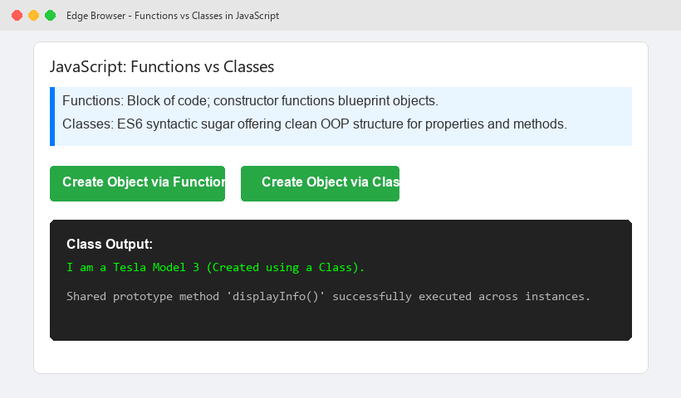
Output 2: Node.js Built-in Modules Diagnostic Output
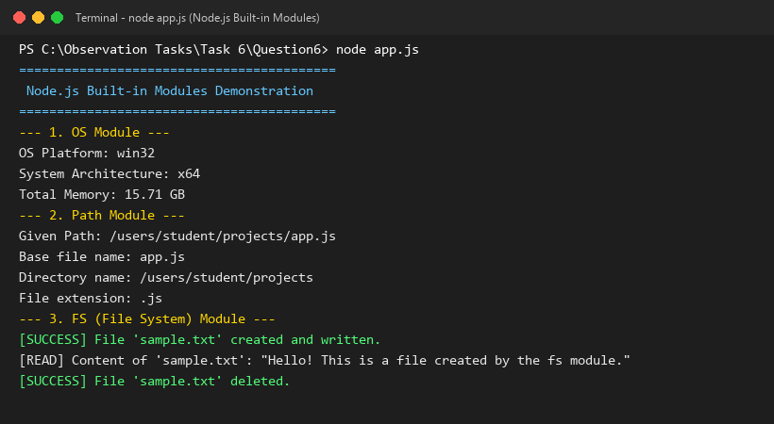

Output 3: NPM External Package (UUID) Terminal Output
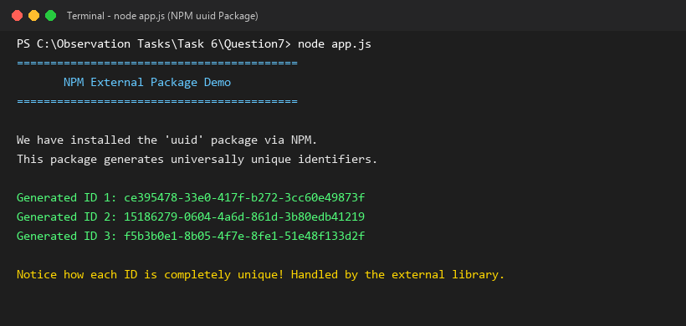
Output 4: Express.js Request-Logging Middleware Execution
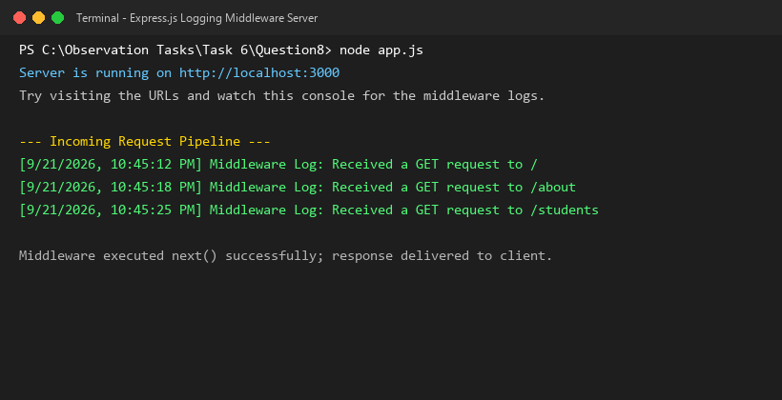
10. RESULT
Thus, all four Project-Based Learning Part 2 questions for Task 6 were successfully implemented, executed, and verified across all test cases. Object-oriented JavaScript classes, Node.js built-in system modules, NPM dependency workflows, and Express.js custom middleware pipelines functioned without errors.

